## Creating a Twist from Tropes

Your individual assignment for this week is to research the top three genres you chose in the Genre Interest Survey. For each genre, choose a game and identify 3-4 tropes it exemplifies from that genre. Twist one of the tropes and remove one. Create a one paragraph description of a new game idea based on the twist and include a sketch. An example is provided below for one genre (Platformer). You will use the results of this exercise to come up with an idea for your Paired Prototype project with your assigned team next week.

# 

## Genre Research & Twist Example

### Genre | Game Name:

Puzzle – Crossword

### Tropes:

Wordplay, clue-based puzzle solution, reusable letters.

### Twist:

### The word once filled moves to a different position in the crossword square. This unlocks another clue for the word that coincides with it. Time restriction is gone.

### Description:

This is a twist on the concept of crosswords. Each time you fill up a word using clues, use the letter blocks to fill up empty space in the crossword square. Once a row is filled, it gets cleared (just like Tetris). The goal is to fill up the square using wordplay.

### Sketch:

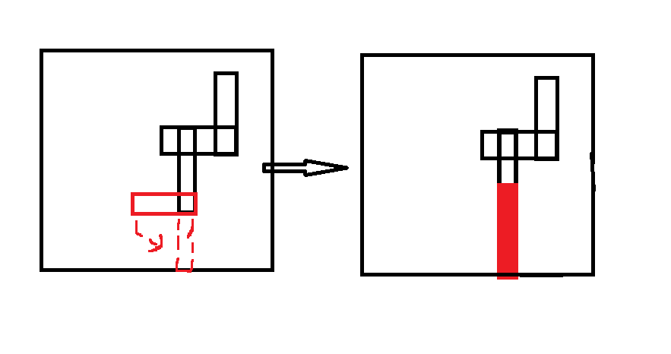

### Genre | Game Name:

Strategy – FM – Football Manager

### Tropes:

Football, Management, Strategical decisions, Team building.

### Twist:

### Twist to this game is that we can add an actual football gameplay to it rather than it being just a simulator game. This will make it more engaging and would help you make decisions for your team even better. A generalized approach for the development of players should be taken, rather than focusing on players that the user might end up playing.

### Description:

This is a twist on the concept of crosswords. Each time you fill up a word using clues, use the letter blocks to fill up empty space in the crossword square. Once a row is filled, it gets cleared (just like tetris). The goal is to fill up the square using wordplay.

### Sketch:

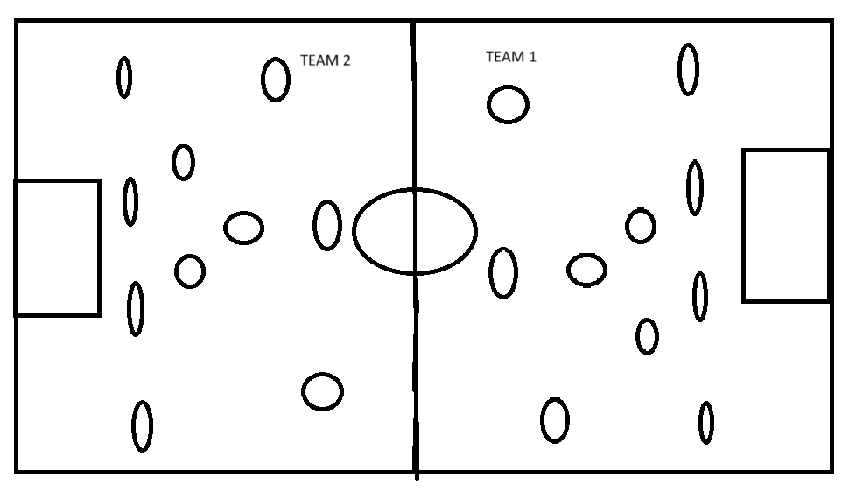

### Genre | Game Name:

Adventure – GTA

### Tropes:

Shooting, driving, missions, killing enemies.

### Twist:

### The twist here is that the game lets you play the cop’s side of the story as well. One trope that goes with it is restrictions on what cops can do other than missions and side missions in the game.

### Description:

In this game, the game switches from thief’s POV to cop’s POV throughout the storyline. This makes decision making even difficult as every decision made affects how the story progresses. At the end, there is a tough choice to be made whether to control the cops or thief for the final showdown.

### Sketch:

